

CERTIFICATE OF
FORMATION
(Limited Liability Company For New Jersey)

This form may be used to record the formation of a Limited Liability Company under and by virtue of New Jersey State law. Applicants must insure strict compliance with NJSA 42, the New Jersey Limited Liability Company Act, and insure that all applicable filing requirements are met. Applicants are advised to seek out competent legal advice before submitting filings to the
Secretary of State’s office.
1. Name of the Limited Liability Company: (name must include the words, “Limited Liability
Company” or the abbreviation, “L.L.C.”).

2. The purpose for which this Limited Liability Company is organized is to: (This is an optional field.)

3. Date of formation: (May be left blank. If this field is left blank, the date of formation will be the
date on which the Certificate of Formation is filed in the office of the Secretary of State.)
____________________________________________ , 20 _______
4. Registered Agent Name and Address (must be in New Jersey): (May be an individual resident
of this State whose business office is identical with the LLC’ s registered office, or a domestic or for
eign authorized Corporation having a business address identical with the LLC’s registered office.
Office must be located in New Jersey.)

5. Dissolution date is: (If desired, enter the specific date of dissolution in this field.)
____________________________________________ , 20 _______
6. Other provisions (list below or attach to certificate):
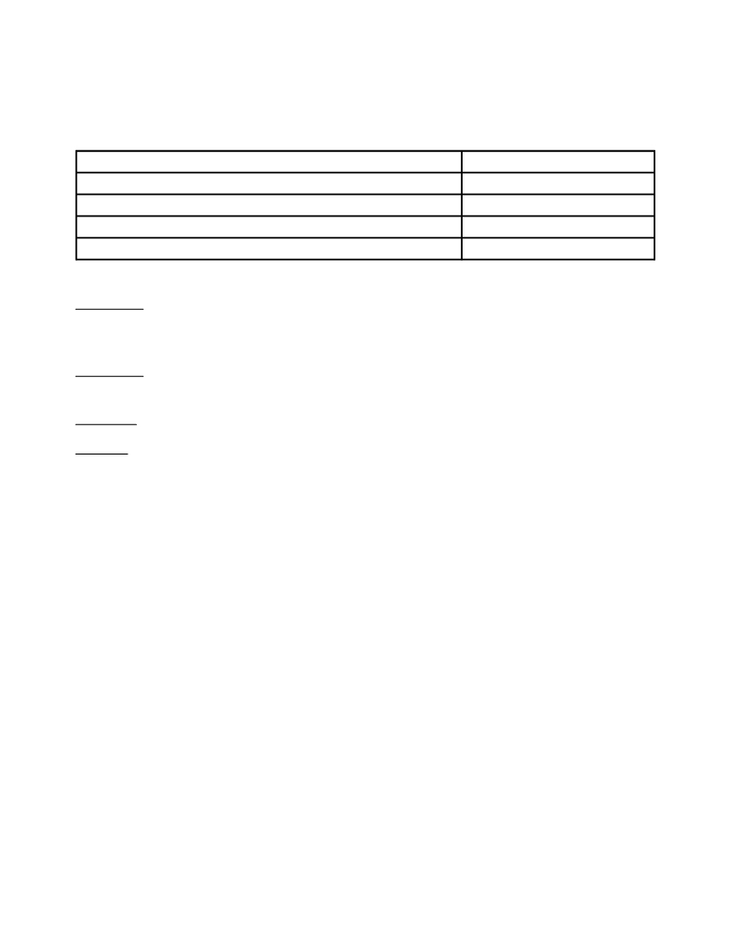

The undersigned represent(s)-that this Limited Liability Company has one or more members, and that this filing complies with requirements detailed in N.J.S.A. 42. The undersigned hereby attest(s) that they are authorized to sign this certificate on behalf of the Limited Liability Company.
Name Date

Instructions: Type all information except signatures.
Form must be completed and filed in duplicate.
The original document will be retained by the Division of Commercial Recording.
Remittance: Check or Money Order should be signed and made payable to the Secretary of
State, and be submitted with the document to be filed.
Filing Fee: Contact Secretary of State’s Office
Address: Regular Service Expedited Service
(by regular mail) (by messenger or in person)
Department of State Department of State
Division of Commercial Recording Division of Commercial Recording
P.O. Box 308 820 Bear Tavern Rd., 2nd Floor
Trenton, NJ 08625 Trenton, NJ 08628
Expedited Service requests must be delivered in person or by messenger service such as Federal Express, Emery, UPS, or any overnight service, but not U.S. Postal Service Overnight because it does not directly deliver to our division office.
Please use zip code 08625 for regular mail. Regular mail wrongly addressed to the “Expedited Service” zip code, 08628, will be returned “undeliverable” by the local Post Office.

