

CERTIFICATE OF
REGISTRATION
Limited Liability Partnership for New Jersey

This form may be used to record the registration of a domestic Limited Liability Partnership under and by virtue of New Jersey State Law. Applicants must insure strict compliance with NJSA 42:1-1 and insure that all applicable filing requirements are met. Applicants are advised to seek out competent legal advised before submitting filing to the New Jersey Secretary of State’s office.
The undersigned hereby apply for status as a Limited Liability Partnership, and that this filing complies with requirements detailed in NJSA 42:1-1, the Uniform Partnership Law.
1. The name of the Limited Liability Partnership is:

2. The purpose for which this Limited Liability Partnership is organized is to:

3. The Name and Address of the Registered Agent is:

4. The Address of its Principal Office is:

5. Other provisions: (list below or attach to certificate)

6. There are _____________ partners in the Limited Liability Partnership:
7. The effective date, if the registration is to be effective upon filing is:
__________________________ , 20 _____
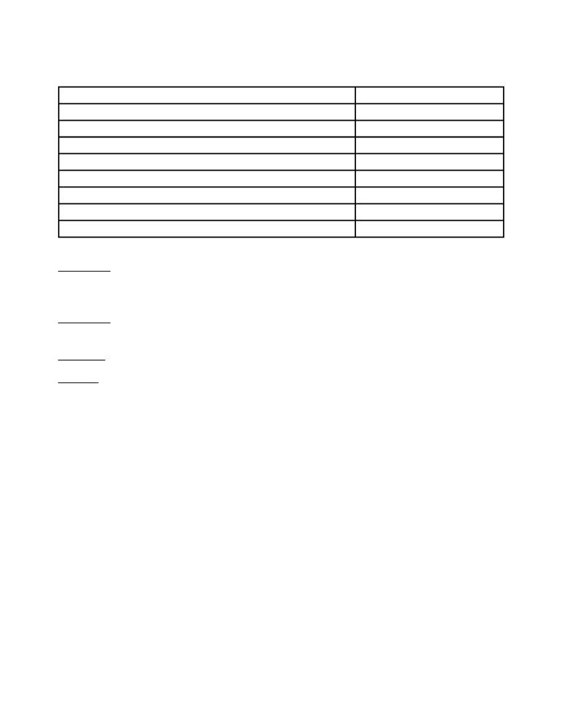

The undersigned hereby attest(s) that they are authorized to sign this certificate.
Name and Signature(s) Date

Instructions: Type all information except signatures.
Form must be completed and filed in duplicate.
The original document will be retained by the Division of Commercial Recording.
Remittance: Check or Money Order should be signed and made payable to the Secretary of
State, and be submitted with the document to be filed.
Filing Fee: Contact Secretary of State’s Office
Address: Regular Service Expedited Service
(by regular mail) (by messenger or in person)
Department of State Department of State
Division of Commercial Recording Division of Commercial Recording
P.O. Box 308 820 Bear Tavern Rd., 2nd Floor
Trenton, NJ 08625 Trenton, NJ 08628
Expedited Service requests must be delivered in person or by messenger service such as Federal Express, Emery, UPS, or any overnight service, but not U.S. Postal Service Overnight because it does not directly deliver to our division office.
Please use zip code 08625 for regular mail. Regular mail wrongly addressed to the “Expedited Service” zip code, 08628, will be returned “undeliverable” by the local Post Office.

