

DISCHARGE OF
CONSTRUCTION LIEN CLAIM

TO THE RECORDING OFFICER, COUNTY OF ____________________________________________
1. The Claimant whose name is _____________________________________________________________
and whose address is ___________________________________________________________________
filed a CONSTRUCTION LIEN CLAIM against the below stated real property (called the “Property”)
owned by _______________________________________________________________ for the value of
work, services, materials or equipment provided in accordance with a contract between the Claimant
and;
2. The Property is described as Block ___________________________ , Lot ______________________ ,
on the Tax Map of the __________________________________________________________________
of _____________________________________ , County of ___________________________________ ,
State of New Jersey.
3. The lien claim was filed on ___________________________ , _____ as No. ______________________
in Bookat ______________________________ Page ________________________
4. A Notice of Unpaid Balance and Right to File Lien (if any) was filed as No. ___________________
in Book ______________________________ at Page __________________

5. Amendments to the original claim were recorded in Book _____________________________________
at Page __________________
6. DISCHARGE. I hereby request and authorize the CONSTRUCTION LIEN to be DISCHARGED.

Date: ___________________________ , _____ Signed: ________________________________________
Name/Title: ________________________________________
On Behalf of: _______________________________________
Note: This form must be signed by the Claimant or the Attorney for the Claimant.
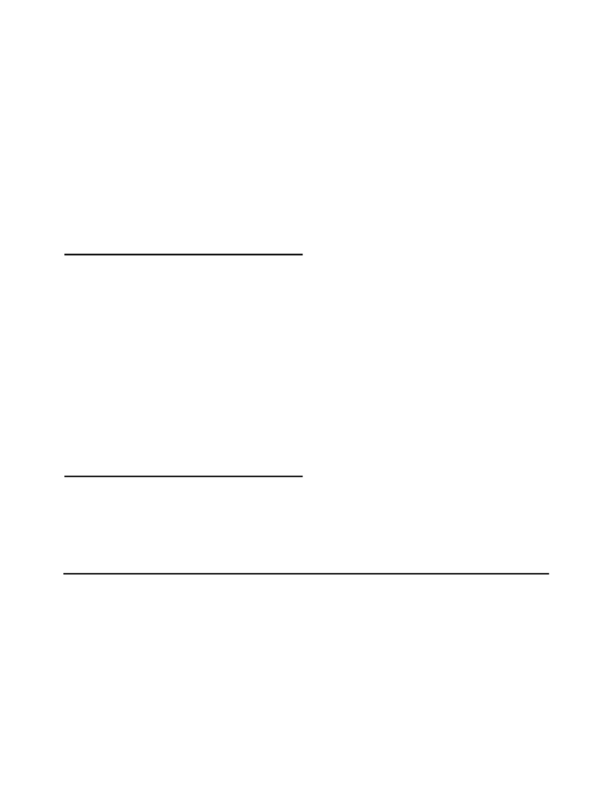

Acknowledgments (Complete Applicable One)

STATE OF NEW JERSEY, COUNTY OF ___________________________________ SS.:
I CERTIFY that on ____________________ , 20 ____,
________________________________________________ personally came before me and stated to my satisfaction that this person (or if more than one, each person):
(a) was the maker of this instrument; and, (b) executed this instrument as his or her own act.

(Print name and title below signature)

STATE OF NEW JERSEY, COUNTY OF ___________________________________ SS.:
I CERTIFY that on ____________________ , 20 ____,
________________________________________________ personally came before me and stated to my satisfaction that this person (or if more than one, each person):
(a) was the maker of this instrument
(b) was authorized to and did execute this instrument as ____________________________________________
of ____________________________________________ the entity named in this instrument; and,
(c) executed this instrument as the act of the entity.

(Print name and title below signature)

RECORD AND RETURN TO:

(For Recorder’s Use Only)

